Integrated Care Matters Webinars Series 11

Community Hospitals across the Globe

16 September 2026 4-5:30pm BST (5-6:30pm CEST)

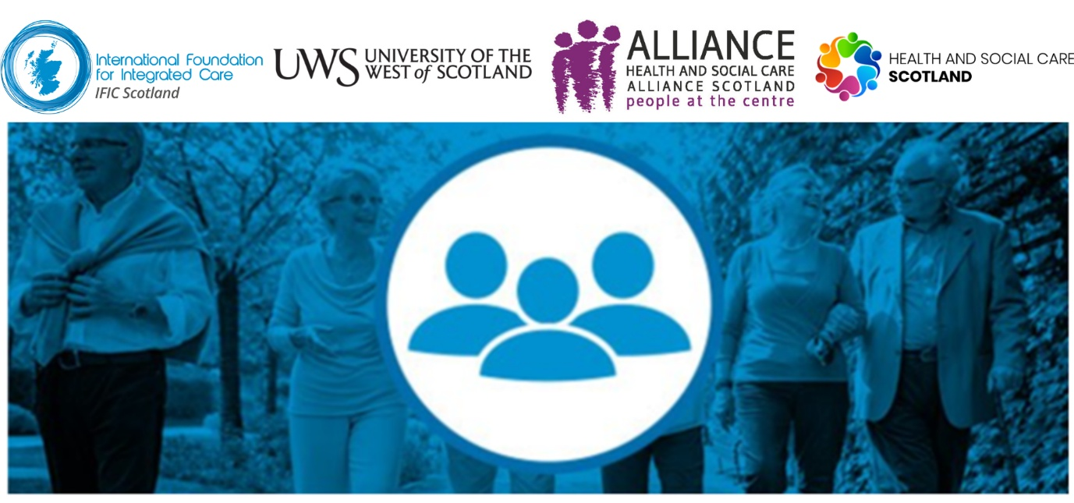

This webinar will consider the important role of community hospitals and subacute hospitals to the delivery of integrated care, rehabilitation, and intermediate care closer to home.
We are pleased to co-host this session with the UK Community Hospitals Association, a membership organisation that supports those involved in community hospitals through networking, sharing quality improvements, and contributing to evidence through research.
Guest speakers will compare and contrast models of bed-based intermediate care from the UK, Italy, and Malta, adding further insights and examples to our growing international community of practice on this topic.
Join us for #IntegratedCareMatters11

Register in advance for this webinar here
Co-Hosts
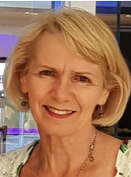 | 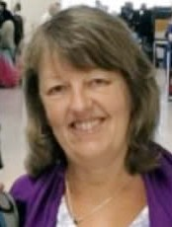
Prof Anne Hendry, IFIC Senior Associate and Director, IFIC Scotland | Dr Helen Tucker Dickson, Past President UK Community Hospitals Association, Visiting Research Fellow, University of Winchester

Presenters
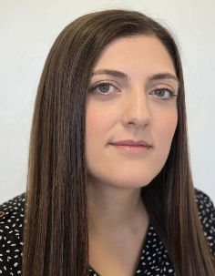 | Dr Francesca Farrugia, Resident specialist in geriatrics and general medicine, Malta  Francesca currently works in the intermediate care unit and frailty clinic at Malta’s St. Vincent de Paul facility, a community campus that provides long-term care, ambulatory and intermediate care. She graduated as a Doctor of Medicine and Surgery in 2015, obtained a Master of Arts in Ageing and Dementia Studies in 2020 and a Postgraduate Certificate in Patient Safety and Clinical Risk Management in 2021 from the University of Malta. Her main academic interests are dementia, frailty and integrated care. Francesca has spent time with several Hospital at Home services in the UK.
Imma Cacciapuoti, Director AUSL Modena, Emilia-Romagna  Imma has extensive experience in the development of Community Hospitals and, more broadly, community-based care both at the Local Health Authority level in the Emilia-Romagna region of Italy. She is director of the Local Health Unit in Modena. |  | 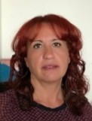
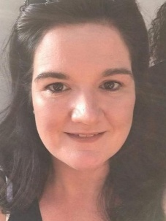 | Sarah Handby, Senior Delivery Manager, NHS Benchmarking Network  Sarah has over 15 years' experience in healthcare data, benchmarking and service quality improvement. She leads national programmes that help NHS organisations use their data and insight to drive better decision-making, improve services and deliver better outcomes for patients. Sarah will share highlights from benchmarking work with Community Hospitals in the UK.

Register in advance for this webinar here

